Documentation on File Booking

First set up booking officer
To setup booking officer login as admin/super admin and go to user page
Click on edit user icon
Add/ Edit user window will open
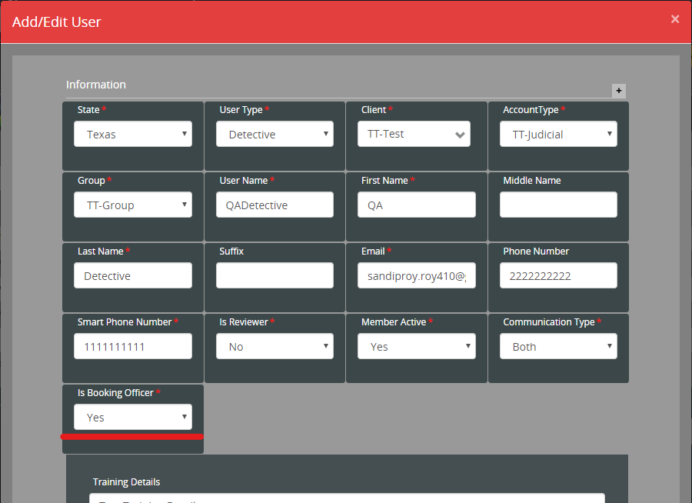
Select ‘Is booking officer’ as Yes
Click on Save
User is ready as a booking officer

Stapes to send a warrant for booking

Create a Warrant and send it to Judge
Login as a Judge
Click on Approve Warrant Action from action menu
Approve Warrant window will open
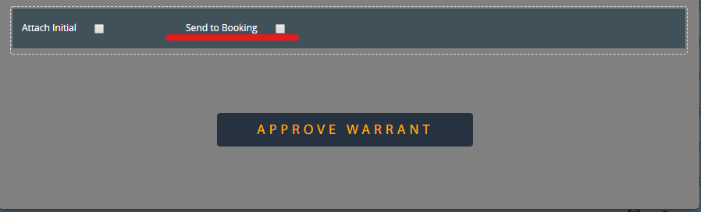

To send a warrant to booking officers check Send to Booking option and click on Approve Warrant button. You can also approve a warrant without marking Send to Booking option.
If warrant is approved with marking Send to Booking option then all booking officers will get a email with ‘Warrant Sent for Booking’ subject line.
The new status of the warrant will be Judge Approved - Auto Sent To File.

To sent a Judge Approved - Auto Sent To File to File Record add below action mapping
